3. TEST RESULTS

1. Rectifier test

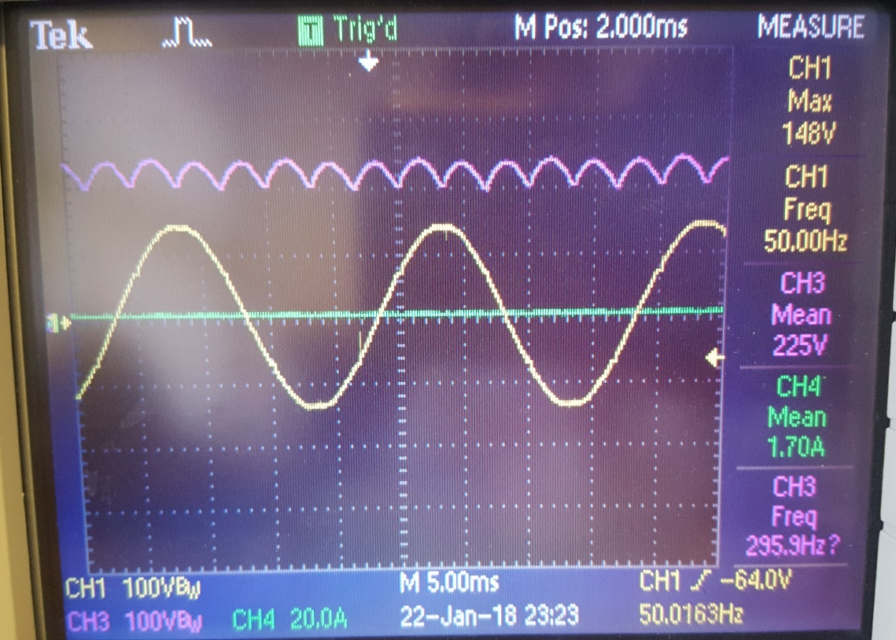

Figure ?. Input voltage waveform and 3-phase rectifier output voltage waveform

V­o = 1.35×VL-L

Using 3-phase bridge rectifier, we got a 6-pulse output voltage as shown above

1. Pulse Width Modulation using Arduino

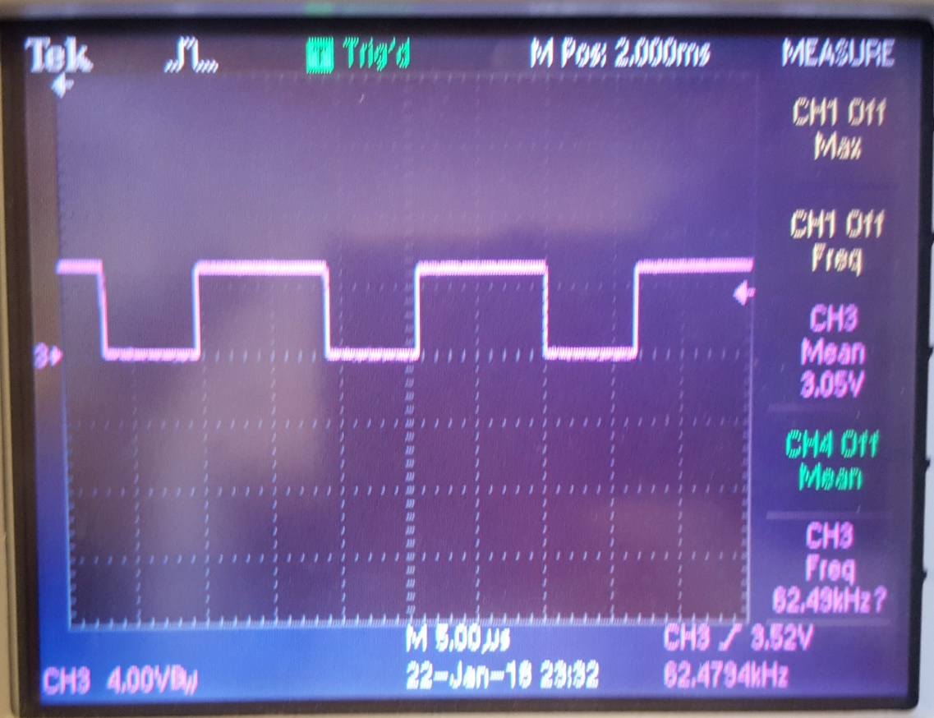

Figure?. Arduino PWM output

Duty cycle of PWM was varied using a potentiometer connected to A0, 5V and GND pins to Arduino, and output taken from PWM-5 pin

1. R-Load test of Buck Converter

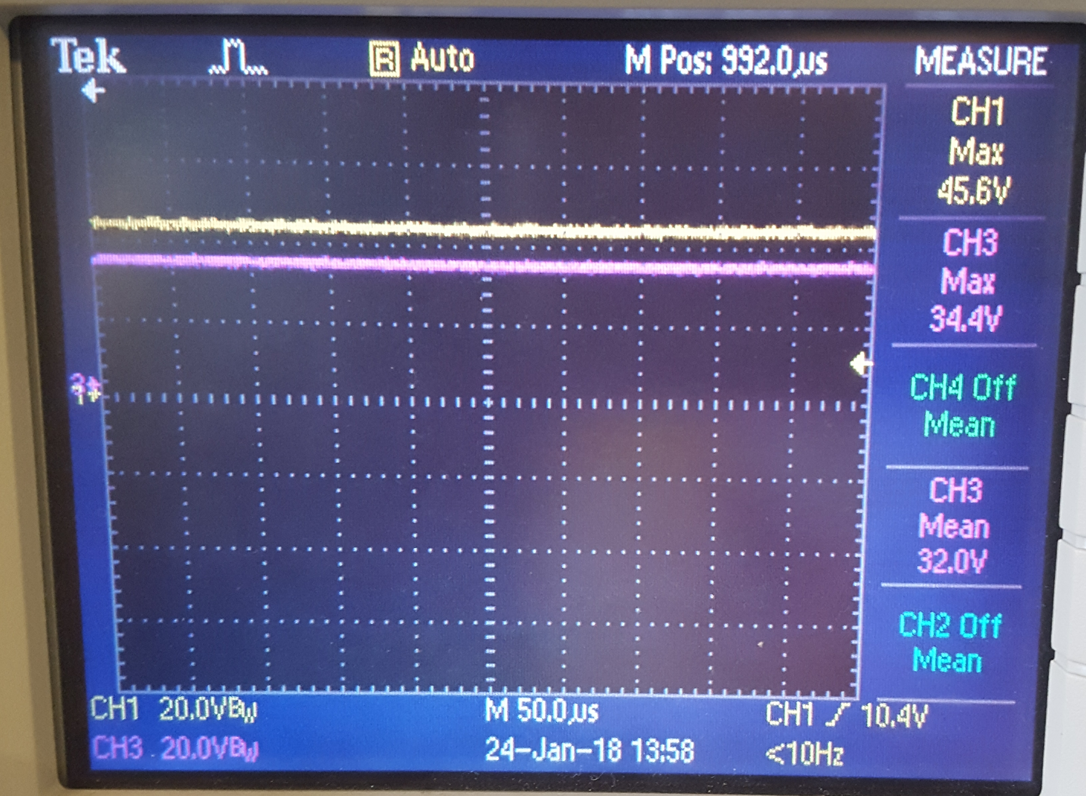

Figure ?. Output voltage waveform at 75% duty cycle

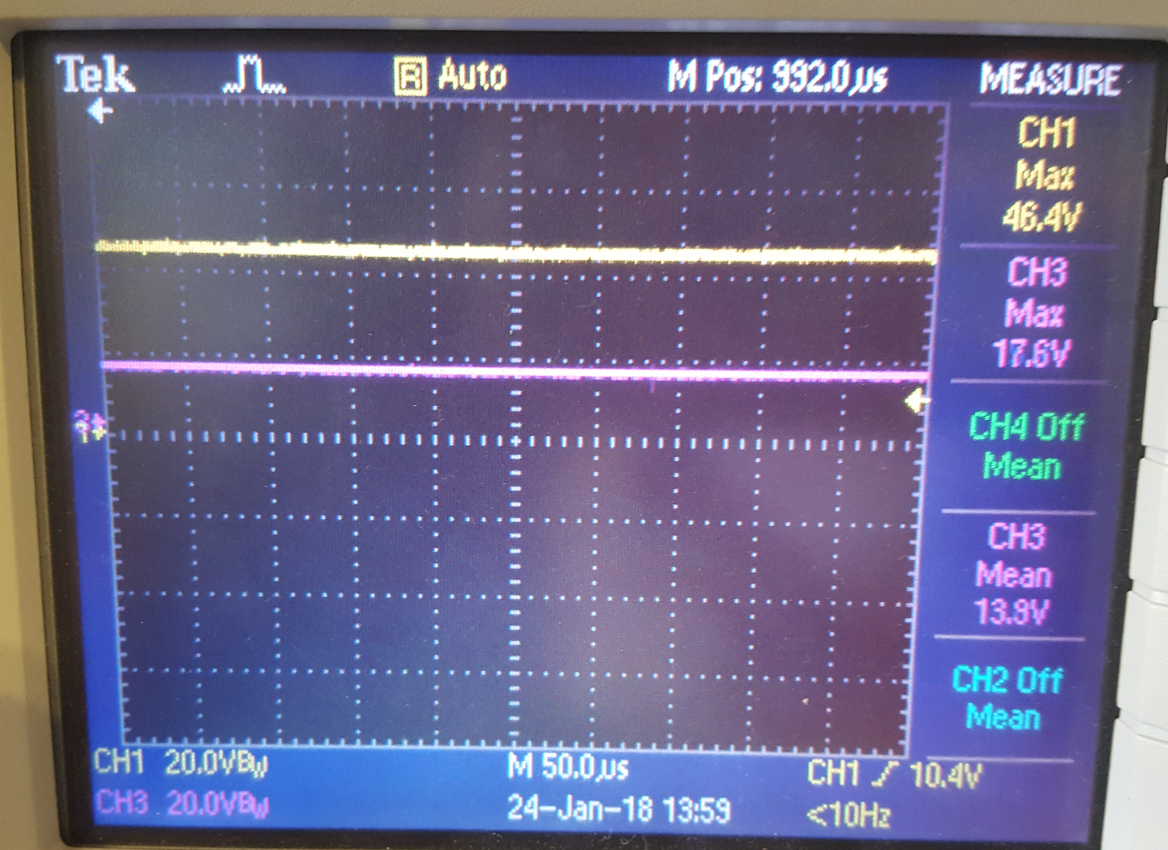

Figure ?. Output voltage waveform at 37% duty cycle

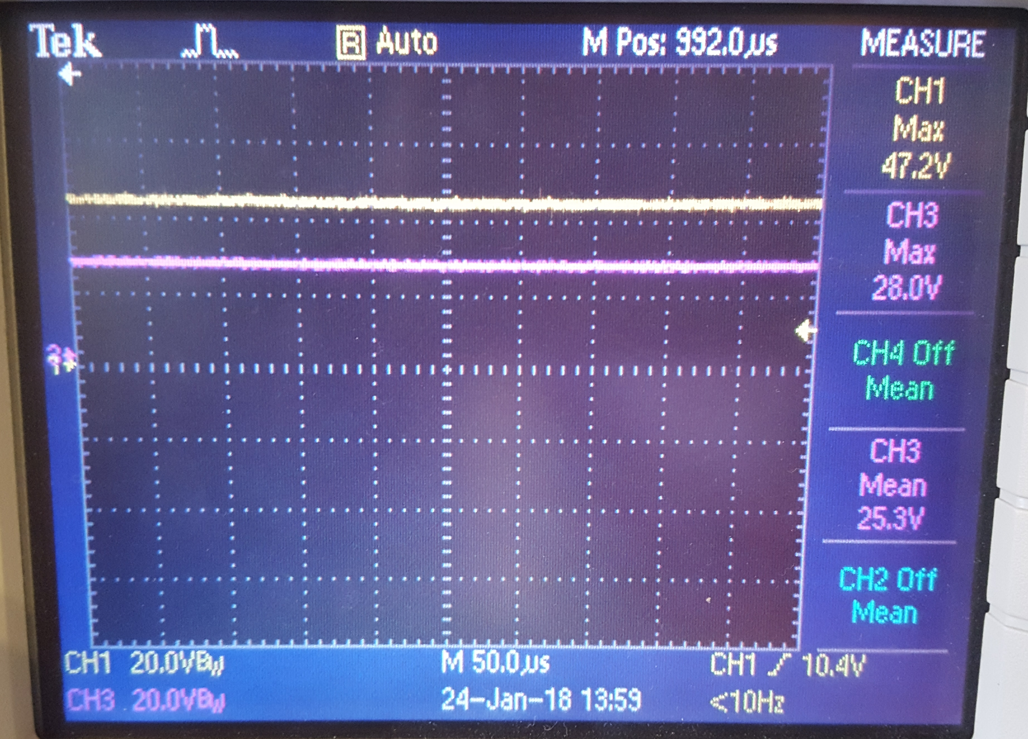

Figure ?. Output voltage waveform at 59% duty cycle

Vo= D × Vd (D- duty cycle, Vd- Rectifier output voltage)

The output voltage was successfully varied in a controlled manner without any distortion, however current waveform had a significant distortion with high THD value

1. RL-Load test of buck converter

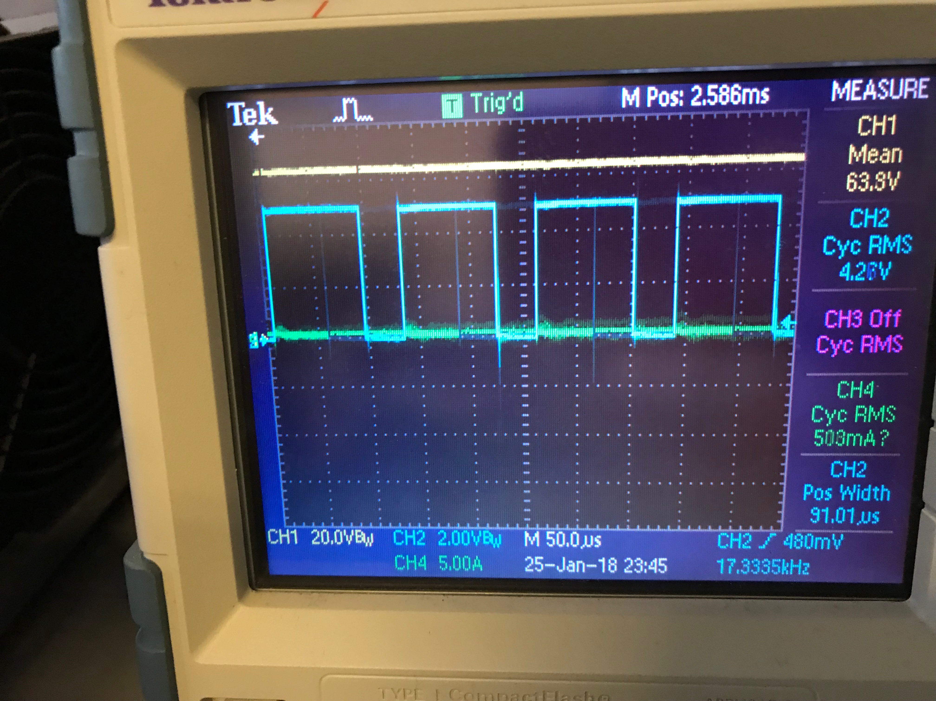

Figure ?. Output voltage waveform at 85% duty cycle

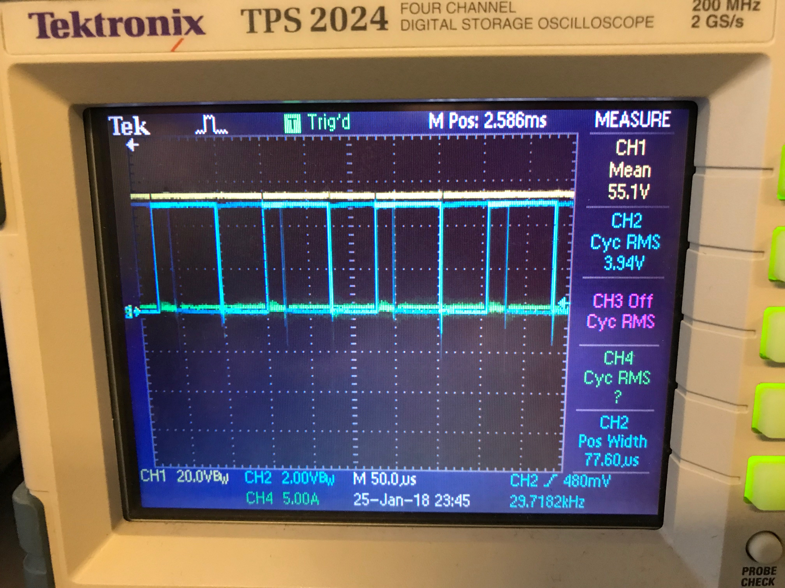

Figure ?. Output voltage waveform at 50% duty cycle

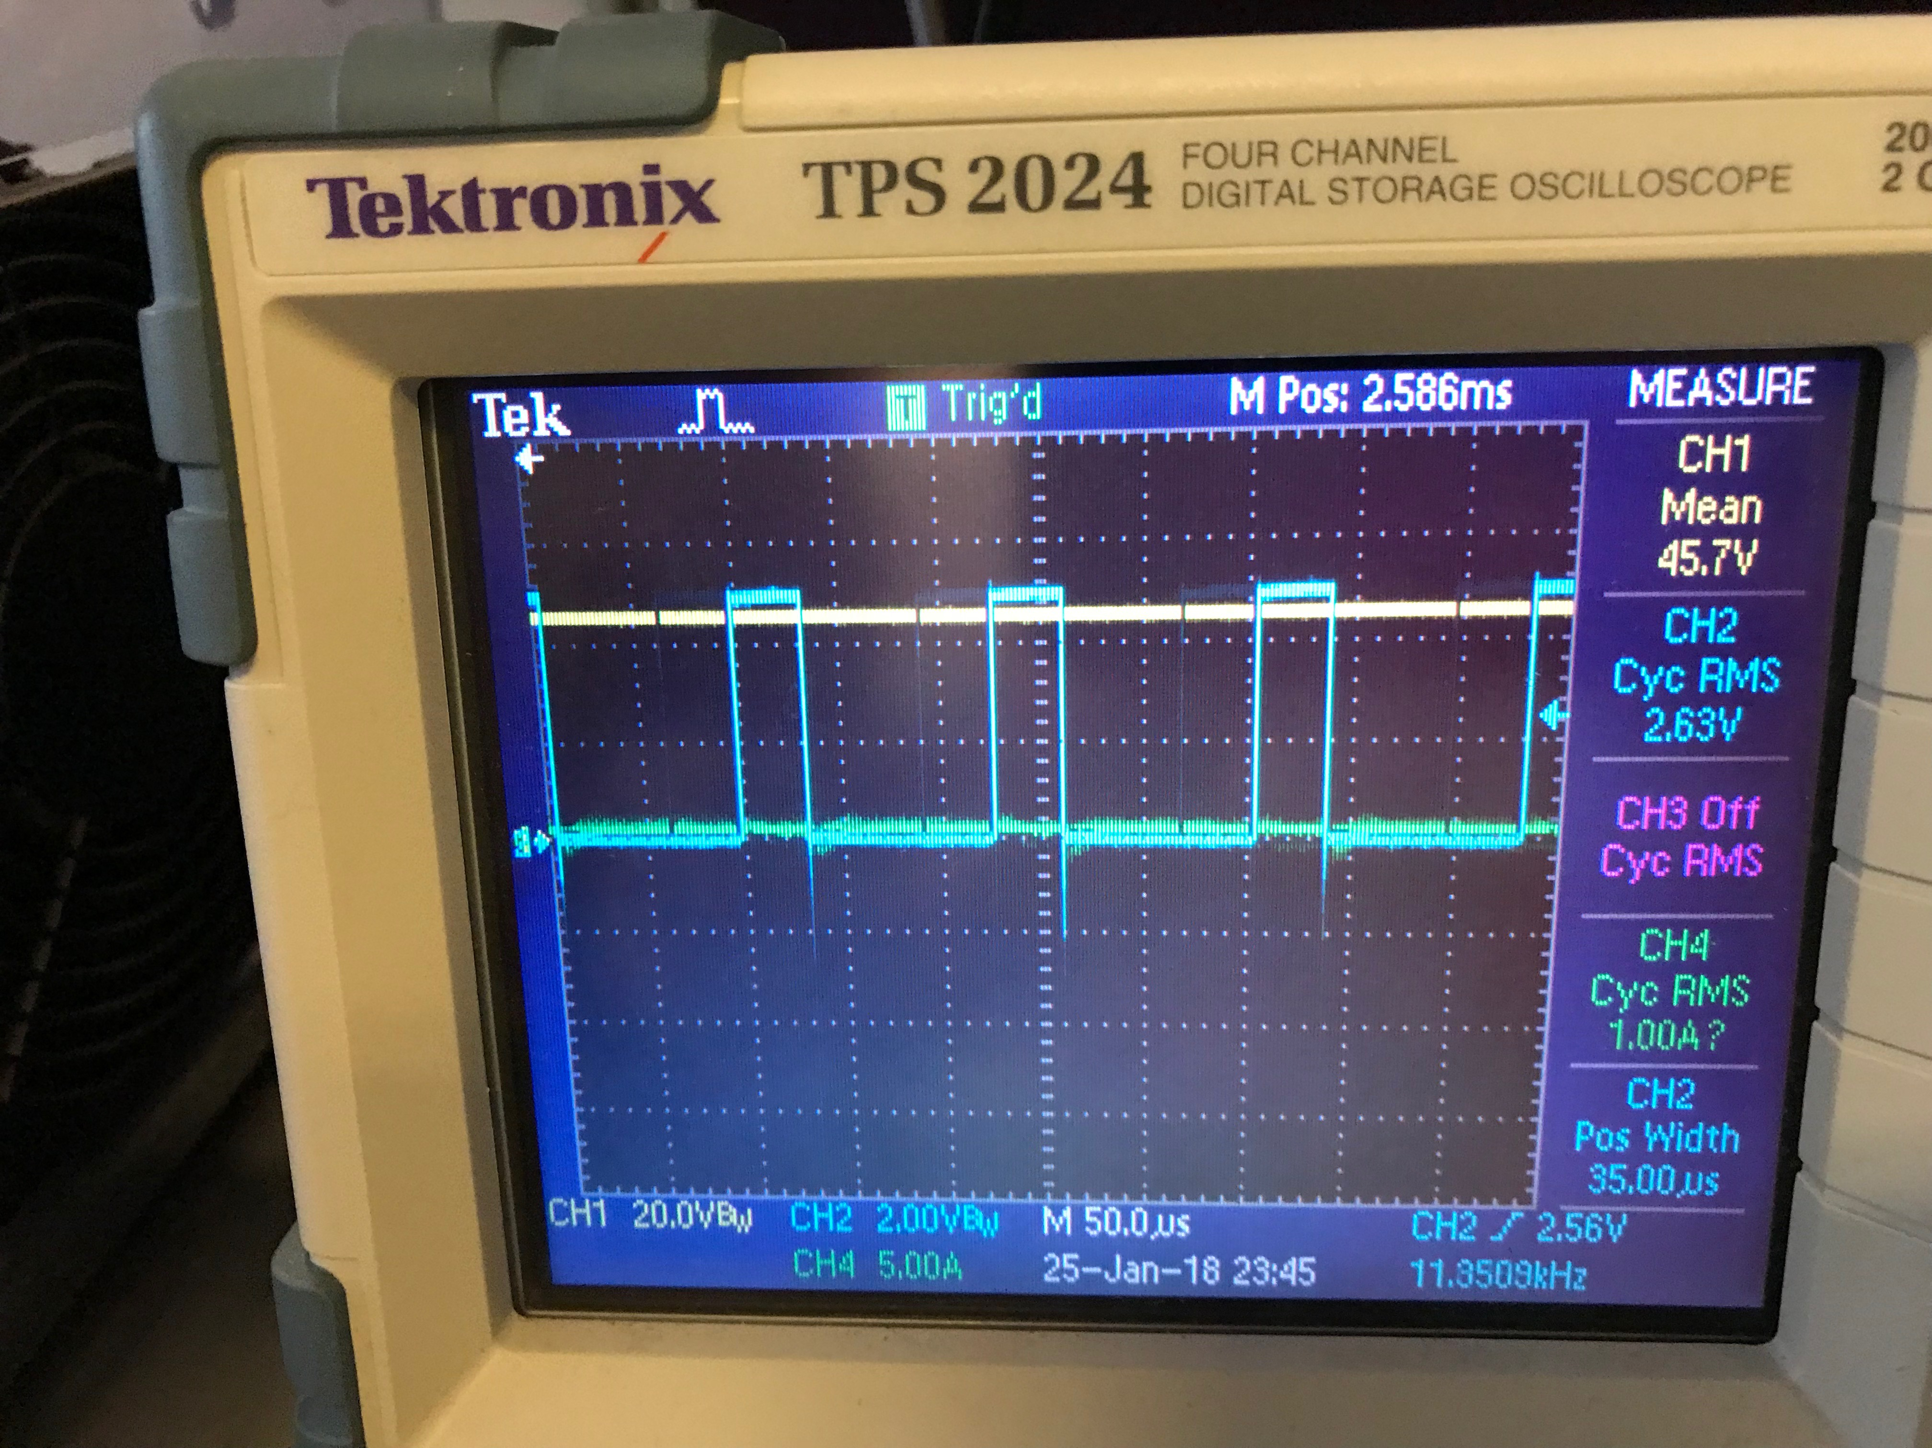

Figure ?. Output voltage waveform at 15% duty cycle

RL-Load test is the preliminary step before going to motor drive test, and results that were obtained turned out to be encouraging. After getting this results, we performed the motor drive operation successfully